https://www.farandwide.com/s/most-spoken-languages-eebb682e26eb4bc5
https://www.trustedtranslations.com/spanish-language/history-of-spanish/in-spain
https://www.wiracochaschool.org/blog/the-history-of-the-spanish-language.html

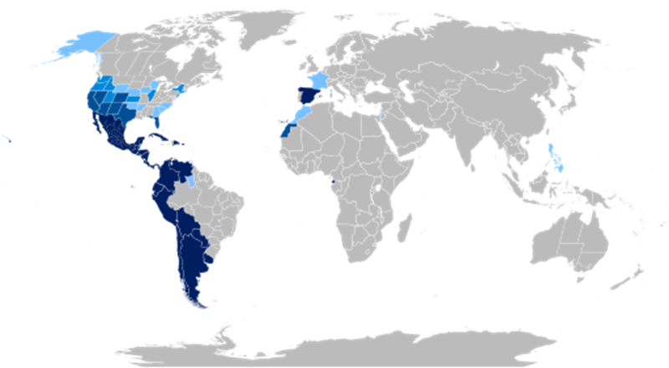
Spain: origin of Spanish language

Good for describing the tree diagram:
https://www.wiracochaschool.org/blog/the-history-of-the-spanish-language.html
